# Project Discovery for Secure ML using SQL Server Machine Learning

## See the source image

## Contoso Secure Manufacturing

## 1234567 / Discovery Phase / AI and ML

### 07/07/2018

### Tampa, Florida, USA

## Attendees

|  |  |  |
| --- | --- | --- |
| Contact | Role | Notes |
| J. Smith | [Microsoft Architect](https://microsoft.sharepoint.com/:w:/r/sites/Infopedia_G04KC/Programs/_layouts/15/WopiFrame.aspx?sourcedoc=%7b2ebf5d5c-5e11-44e4-93c9-27b513da591e%7d&action=default&DefaultItemOpen=1) | Microsoft Technical Team |
| B. Williams | Contoso Architect |  |
| K. Johnson | Contoso Project Manager |  |
| O. Prasath | Contoso IT Director |  |
| E. Yang | Contoso Manufacturing Lead |  |
| B. Woody | Microsoft Data Scientist |  |
| Q. Samanth | Contoso Data Scientist |  |
| W. Difier | Contoso Security Team |  |

## General Opportunity Statement

Contoso Secure Manufacturing creates and repairs components for highly secure solutions. They wish to create a Predictive Maintenance solution whereby they keep all data on-premises, but train a predictive model at a remote location. Sample, anonymized data must be used in the training. Ideally, the model created would be used in the testing phase of manufacturing for quality control, and also be deployable to an IoT device as an add-on service for the equipment once deployed.

## Discussion Items:

* Security – How best to train remote and operationalize locally
* Data – How to create sample data that represents local data, without compromising actual production security
* How best to arrange a project – who, what, when and where

**Contoso Secure Manufacturing and Repair:**

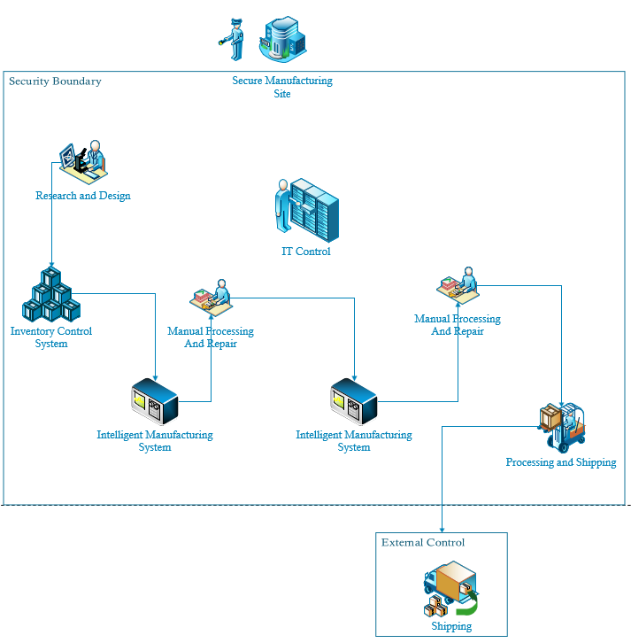

## Follow-up:

1. Microsoft teams to meet for Envisioning preparation
2. Follow-on meeting for Envisioning discussion